FasalNetra: An Agentic AI Platform for Crop-Loss Claim Assessment
Agile DevOps and Software Project Management Report

FasalNetra: An Agentic AI Platform for Crop-Loss Claim Assessment


Agile DevOps and Software Project Management
Submitted to: Prof. Gaurav Abhishek Tigga
Submitted by:

1. Executive Summary
Indian crop insurance covers crores of farmers, yet the claim process remains slow, manual and disputed. When a hailstorm, flood or pest outbreak damages a single farm, a surveyor must physically visit, estimate the loss, and file paperwork that insurers then reconcile. Settlements take months, farmers lose trust, and insurers carry high loss-adjustment costs and fraud leakage.
TerraTrust Technologies is a software startup that builds FasalNetra, an agentic AI system that automates the end-to-end assessment of localized crop-loss claims. A farmer reports a loss through a voice-enabled mobile or WhatsApp channel. A coordinated set of AI agents validates the policy, gathers satellite and weather evidence, estimates damage from photographs, screens for fraud, and recommends a settlement with a plain-language explanation. Humans stay in control of every adverse or low-confidence decision.
This report applies the concepts taught in the course: the triple constraint, Scrum and Kanban, user stories and story maps, sprint and release planning, TDD/BDD, CI/CD and DevOps, retrospectives, and scaling frameworks. It follows the assignment structure: startup context, requirements, SDLC and constraints, feasibility, HLD and LLD, testing, deployment, and regulatory compliance.

2. Startup Context and Strategic Objectives
Startup profile. TerraTrust is an IT/ITES product startup. Our only output is software: we do not sell consulting or surveying services. Our client is a general insurer (referred to as "the Client") that underwrites crop insurance under government-sponsored and private schemes.
Vision. Reduce crop-claim settlement from months to days, with evidence a farmer can understand.
Strategic objectives (SMART).
- Deliver a pilot-ready MVP within six months and a production release within nine months.
- Reduce average claim assessment time by at least 60% against the Client's baseline during the pilot.
- Achieve at least 85% agreement between FasalNetra's loss estimate and expert surveyor estimates on a held-out validation set.
- Reduce physical field visits by at least 40% by routing only uncertain claims to surveyors.
- Maintain zero critical compliance findings in the pre-launch security and privacy audit.
Team and roles (five members).
Role | Responsibility
Product Owner (PO) | Owns the backlog, liaises with the Client, prioritizes value
Scrum Master / Project Manager | Facilitates events, removes impediments, tracks the triple constraint
ML Engineer | Satellite and vision models, agent evaluation
Full-Stack and Integration Engineer | Backend services, APIs, mobile/WhatsApp channels
DevOps and QA Engineer | CI/CD, infrastructure, test automation, security

3. Problem Statement and Client Needs
Crop insurance claims fall into two broad types. Area-yield claims are settled from Crop Cutting Experiments at administrative-unit level. Localized-calamity and post-harvest claims, such as hail, flood or cyclone, need individual-farm assessment, and farmers must usually intimate the loss within a short window (typically 72 hours). Individual assessment is where delays and disputes concentrate.
Core pain points.
- Surveyors are too few for the volume of claims after a regional disaster, so queues build up.
- Estimates vary between surveyors, which causes disputes and appeals.
- Fraud (inflated area, recycled photographs, claims outside the insured plot) is hard to detect manually.
- Farmers have limited literacy and connectivity, and need local-language, low-bandwidth channels.
- Insurer systems are legacy, with policy and land data spread across multiple databases.
This is a complex problem: it combines geospatial analysis, computer vision, document intelligence, rule-based policy logic, conversational interfaces, and regulated decision-making. It is deliberately not a simple workflow-automation task.

4. Client Requirements
Requirements were gathered through stakeholder interviews, process observation and document analysis, then classified into the categories discussed in class and prioritized with MoSCoW.
Category | Requirement | Priority
Business | Cut claim cycle time and loss-adjustment cost; improve loss-ratio through fraud reduction; support Client's scheme reporting | Must
Stakeholder / User | Farmer: report loss in local language by voice or photo. Surveyor: receive only prioritized, evidence-packed cases. Claims officer: review, override, and audit AI recommendations | Must
Functional | FR1 claim intake (app, WhatsApp, IVR callback); FR2 policy and eligibility validation; FR3 satellite and weather evidence retrieval; FR4 photo-based damage estimation; FR5 fraud screening; FR6 decision routing; FR7 explanation generation; FR8 officer dashboard; FR9 audit trail | Must
Functional (enhancement) | Predictive early-warning alerts to farmers; multi-language expansion beyond the first three languages | Should / Could
Non-functional | Availability 99.5%; claim triage under 5 minutes per claim; scalability to 50,000 claims in a calamity week; low-bandwidth mode; explainability; WCAG 2.2 AA | Must
System / Technical | Integration with Client policy system through REST/SFTP; land-record and weather-feed APIs; India-region hosting | Must
Regulatory | DPDP Act consent and rights; IRDAI guidelines; ISO/IEC 27001-aligned controls; human review of adverse decisions | Must
Transition | Data migration, pilot in two districts, training for officers and surveyors | Must
Resolving requirement issues. Three conflicts surfaced and were resolved with the Client. First, the Client wanted fully automatic settlement, while regulation and risk appetite demand human oversight; we agreed on automation of recommendation, human approval of adverse or low-confidence outcomes. Second, the Client wanted per-field accuracy that satellite resolution cannot guarantee under heavy cloud cover; we adopted radar (SAR) data plus farmer photographs as fallbacks. Third, voice support in all languages was requested; we scoped the MVP to Hindi, Odia and English and placed others on the roadmap.

5. SDLC Model, Timeline and Constraints
Chosen model: Scrum with a Kanban board for operations and support, delivered through CI/CD.
Justification. Requirements here are uncertain and data-dependent: model accuracy cannot be known until real claims are analyzed. A waterfall plan would lock in assumptions before evidence exists. Scrum gives short feedback loops with the client, supports inspection and adaptation of AI models every two weeks, and allows reprioritization when pilot data reveals surprises. Kanban, with explicit work-in-progress limits, suits the continuous flow of bug fixes, model-drift tickets, and client support requests after release. A light governance gate (a documented Definition of Done and a compliance checklist per release) is added because insurance is a regulated domain; this is a hybrid, not pure Agile.
Assumed timeline.
Phase | Duration | Output
Sprint 0: inception | 2 weeks | Vision, story map, architecture runway, tooling
Sprints 1–6 | 12 weeks | Intake, policy validation, evidence retrieval, basic dashboard
Sprints 7–12 | 12 weeks | Damage model, fraud agent, orchestrator, explanations, hardening (MVP)
Pilot | 12 weeks | Two-district pilot, model tuning
Production release | 4 weeks | Audit, training, staged rollout
Triple constraint and quality.
Constraint | Assumption | Management approach
Scope | MVP covers hail, flood and drought claims for two crops (paddy, soybean) | MoSCoW, backlog refinement, scope is the flexible variable
Time | Fixed: pilot must start before the next kharif season | Fixed sprint length, release train, burn-up tracking
Cost | Seed budget of about ₹1 crore (assumption), mostly staff and cloud | Cloud cost budgets, open satellite data, spot compute for training
Quality (centre) | Accuracy, security, and explainability are non-negotiable. | Definition of Done, TDD/BDD, automated gates
Because time and cost are fixed, scope flexes; quality is never traded off. This reflects the principle that quality sits at the centre of the triple constraint.

6. Feasibility Analysis and Resources
Feasibility was assessed across five dimensions before committing to the build.
Dimension | Findings
Technical | Sentinel-1/2 imagery is free and processable at plot level; pretrained vision models can be fine-tuned with a few thousand labelled images; a conversational layer is available through managed LLM services. Risk: label scarcity, mitigated by using the Client's historical claims and expert annotation.
Economic | Expected savings from reduced field visits and lower leakage exceed projected build and run costs within the second year (cost-benefit and payback analysis to be validated in the pilot).
Operational | Officers keep their current roles; the dashboard replaces spreadsheets. Surveyors shift to exception handling. Change management is planned.
Legal / Regulatory | Feasible if consent, localization and human-review controls are built in from the start (Section 13).
Schedule | Feasible with fixed sprints and the pilot window, provided data access is granted by Sprint 2. A risk register tracks this.
Resources.
- People: five core members, plus a part-time agronomy expert and a legal adviser.
- Data: historical claim records (anonymized), Sentinel-1/2 imagery, IMD rainfall data, land-parcel boundaries, labelled photographs.
- Technology: Python, PyTorch, GeoPandas and rasterio, a workflow-graph framework for agent orchestration, PostgreSQL/PostGIS, object storage, and AWS.
- Tools: Jira or equivalent for the backlog and Kanban, Git for version control, GitHub Actions for CI/CD and Prometheus and Grafana for monitoring.

7. Product Backlog, User Stories, Sprints, and Release Roadmap
The backlog was built using a user story map with the activities: Report loss → Verify → Assess → Decide → Communicate → Learn. Stories follow the INVEST criteria, with acceptance criteria written in Given-When-Then form.
Sample user stories.
ID | Story | Acceptance criteria (summary) | Points
US-01 | As a farmer, I want to report crop damage by voice in Odia so that I do not need to type | Voice converted to structured claim; confirmation read back; works on 2G | 8
US-02 | As a claims officer, I want automatic policy validation so that ineligible claims are filtered early | Checks policy status, crop, notified area, 72-hour window | 5
US-03 | As an ML engineer, I want satellite time-series for a plot so that damage can be corroborated | NDVI and SAR series for 60 days before and after the event | 8
US-04 | As a claims officer, I want a loss estimate with a confidence score so that I know when to trust it | Loss % with confidence band; heatmap overlay | 13
US-05 | As an insurer, I want duplicate or out-of-plot photographs flagged so that fraud is reduced. | Perceptual-hash match, geofence check, risk score | 8
US-06 | As a farmer, I want a clear reason for the decision so that I can trust it. | Explanation in local language, no jargon | 5
Sprint planning. Velocity is estimated by planning poker with Fibonacci points; the initial assumed velocity is 30 points per sprint and recalibrated each sprint. Sprint goals: S1 identity and consent plus intake skeleton; S3 policy validation; S5 satellite evidence; S7 damage model v1; S9 fraud agent; S11 orchestrator and explanations; S12 hardening and security audit.
Release roadmap.
Release | Timing | Scope
R1 – Internal alpha | End of Sprint 6 | Intake, validation, evidence, dashboard
R2 – MVP | End of Sprint 12 | Full agent flow, human review loop
R3 – Pilot | Months 7–9 | Live claims, shadow mode then assisted mode
R4 – Production | Month 10 | Staged rollout, additional languages
Dashboards and Scrum events. A burn-up chart and a cumulative flow diagram expose scope growth and bottlenecks. Daily stand-ups, sprint reviews with the client, and retrospectives are held every sprint.

8. AI Agent Automation Flow
FasalNetra is a multi-agent system with a supervising orchestrator. Each agent has one responsibility, a defined set of tools, and a typed input and output. The large language model (LLM) is used for conversation, document reading and explanation. It is not used to calculate the loss; numeric estimates come from validated vision and geospatial models, which keeps the decision auditable.
Step-by-step flow.
- Intake Agent. Receives voice, text or photographs through the app, WhatsApp or IVR. Speech-to-text and translation produce a structured claim: farmer ID, plot, crop, event type, date. It asks follow-up questions if fields are missing and asks the farmer to capture geotagged photographs.
- Policy Validation Agent. Queries the Client policy system and land records. Checks the policy status, premium payment, crop and season, notified area, and whether intimation falls within the permitted window. Failure triggers a human-reviewed rejection, not an automatic one.
- Evidence Agent. Retrieves Sentinel-2 NDVI, Sentinel-1 SAR backscatter and IMD rainfall for the plot polygon, and verifies that a calamity actually occurred on that date in that location.
- Damage Estimation Agent. Runs a vision model on photographs and an anomaly model on the satellite time-series, then fuses them into an estimated loss percentage with a confidence score.
- Fraud and Anomaly Agent. Checks photo metadata, duplicate hashes, geofence mismatch, plot area inconsistencies, and farmer or agent-level patterns, and outputs a risk score with reasons.
- Decision Orchestrator. Applies routing rules:
  - Confidence ≥ 0.85 and fraud risk low: auto-recommend settlement to the officer queue (fast lane).
  - Confidence 0.60–0.85 or medium risk: officer review with evidence pack.
  - Confidence < 0.60 or high risk: schedule a field survey.
  - Any proposed rejection: mandatory human approval.
- Explanation and Communication Agent. Generates a local-language explanation and sends status updates to the farmer.
- Learning Loop. Final human decisions and survey outcomes are stored as labelled data for retraining, subject to approval and drift review.
Safeguards. Each agent call is logged with inputs, outputs and model version. Tool permissions are least-privilege. Timeouts and retries are defined, and a failing agent routes the claim to a human queue. Prompts are protected against injection from user-submitted text. A kill-switch lets the Client revert to fully manual processing at any time.

9. High-Level Design (HLD)
The architecture is a cloud-native, modular microservices system arranged in layers. Figure 1 shows the overall structure.
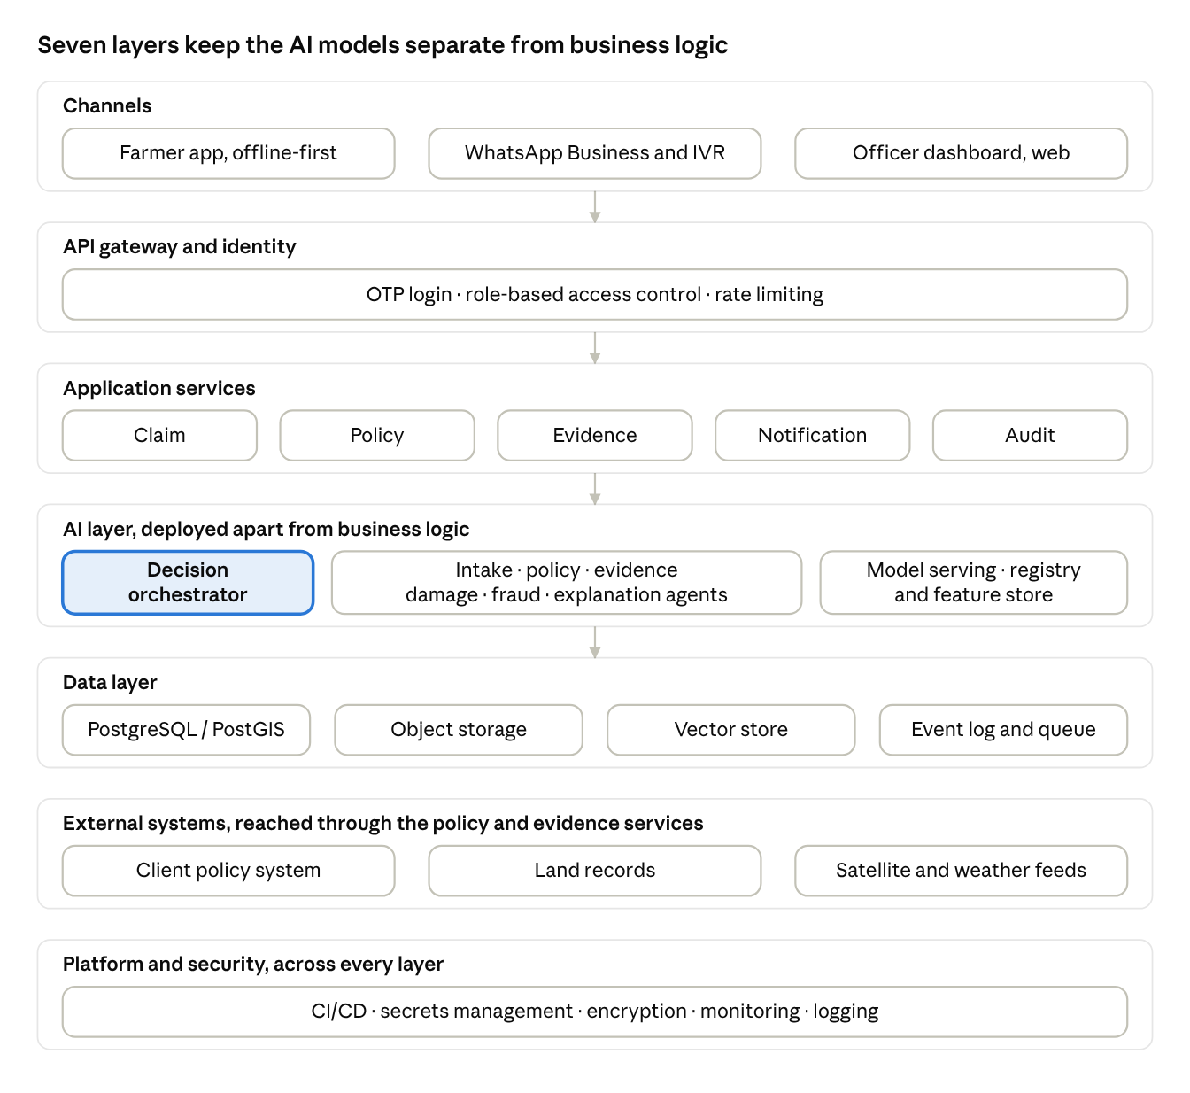
Figure 1 · HLD, seven layers
Figure 1: High-level design. Requests flow down through the gateway, services and AI layer into the data layer; external systems and the platform layer support every service.
Layers.
- Channel layer: farmer mobile app (offline-first), WhatsApp Business API, IVR, and a React-based officer dashboard.
- API gateway and identity: authentication, OTP-based farmer login, role-based access control, rate limiting.
- Application services: Claim Service, Policy Integration Service, Evidence Service, Notification Service, Audit Service.
- AI layer: the orchestrator and the five agents, a model-serving service, a feature store, and a model registry.
- Data layer: PostgreSQL/PostGIS for transactional and geospatial data, object storage for images and rasters, a vector store for policy documents, and an event log.
- Integration layer: Client policy system, land records, Sentinel and weather feeds.
- Platform and security layer: CI/CD, secrets management, encryption, monitoring and logging.
Key design decisions. Event-driven communication through a message queue absorbs the spike in claims after a calamity. Stateless services scale horizontally. The AI layer is separated from business logic so that models can be retrained and redeployed independently. All personal data is stored in an India region.

10. Low-Level Design (LLD)
The LLD details component logic. Figure 2 shows the claim state machine and orchestrator sequence.
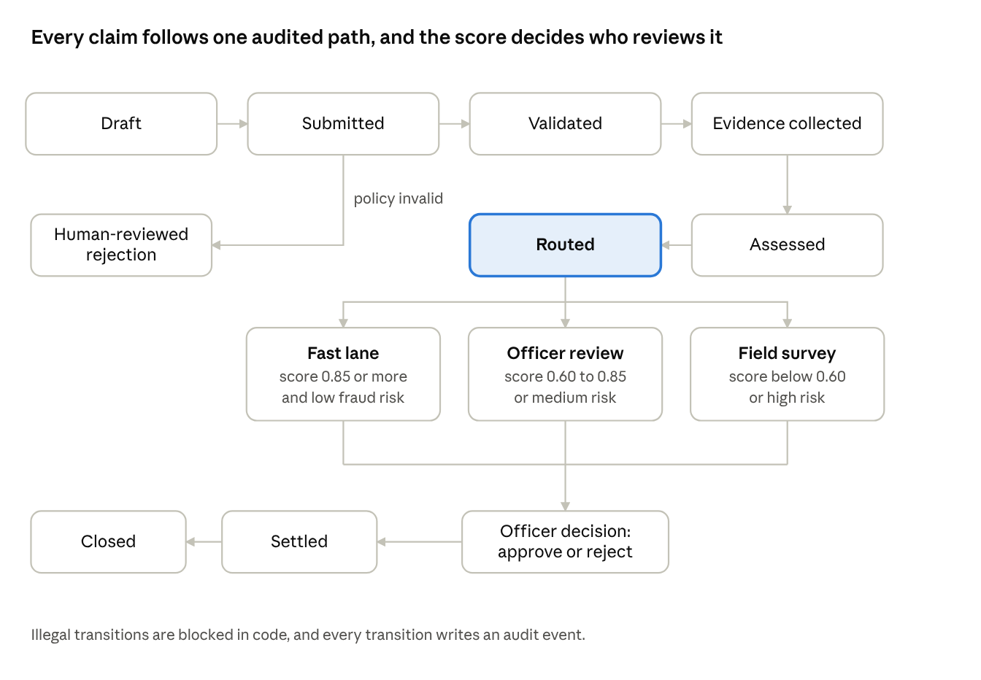
Figure 2 · LLD, claim state machine and routing
Figure 2: Low-level design. The claim state machine, with the routing thresholds used by the orchestrator.
Claim lifecycle (state machine). Draft → Submitted → Validated → Evidence Collected → Assessed → Routed → (Auto-Recommended | Under Officer Review | Field Survey) → Approved or Rejected → Settled → Closed. Illegal transitions are blocked in code, and every transition writes an audit event.
Core data entities.
Entity | Key fields
Farmer | farmer_id, consent_record_id, language, phone_hash
Policy | policy_id, farmer_id, crop, season, sum_insured, notified_area
Plot | plot_id, geometry (polygon), area_ha, land_record_ref
Claim | claim_id, policy_id, plot_id, event_type, event_date, status
Evidence | evidence_id, claim_id, type, source, uri, captured_at, geotag
Assessment | claim_id, loss_pct, confidence, model_version, explanation_ref
FraudSignal | claim_id, rule_id, score, reason
AuditEvent | event_id, claim_id, actor, action, payload_hash, timestamp
Key interfaces.
- POST /claims creates a claim and returns an ID.
- POST /claims/{id}/evidence uploads photographs with metadata.
- GET /claims/{id}/assessment returns loss percentage, confidence and reasons.
- POST /claims/{id}/decision records the officer's decision with justification.
Component logic: damage estimation. The agent crops the plot polygon from imagery, computes the NDVI drop against the plot's own pre-event baseline and a neighbouring-plot control, runs the photo classifier, then applies a weighted fusion: if satellite quality is poor (cloud fraction above a threshold), weight shifts towards SAR and photographs. Output is a loss percentage with a calibrated confidence. Calibration uses temperature scaling on validation data so that a 0.85 score means roughly 85% empirical reliability.
Routing pseudocode.
if not policy_valid: route = HUMAN_REVIEW_REJECTION
elif fraud_risk == HIGH or confidence < 0.60: route = FIELD_SURVEY
elif confidence >= 0.85 and fraud_risk == LOW: route = FAST_LANE
else: route = OFFICER_REVIEW
Error handling. Idempotent APIs, dead-letter queues for failed events, circuit breakers on external integrations, and fallback to human queues when any agent fails.

11. Testing and Quality Assurance
Our quality approach follows the test pyramid: many fast unit tests, fewer integration tests, and a small number of end-to-end tests. Testing is automated in the CI pipeline and gated by the Definition of Done.
Testing methodologies.
Level | Approach | Examples
Unit | TDD: write a failing test, implement, and refactor; target at least 80% coverage on business logic | Policy-window calculation, routing rules, geofence function
Integration | Contract tests with client-system stubs; service-to-service tests in containers | Claim service with policy integration; evidence retrieval
System | End-to-end scenarios, performance and security tests | 50,000-claim load test; penetration testing
UAT | BDD scenarios in Gherkin co-written with the Client; pilot-officer sign-off | See below
BDD example (Gherkin).
Scenario: Claim outside intimation window
Given a valid policy for a paddy plot
And the hail event occurred 10 days ago.
When the farmer submits a claim
Then the claim is flagged for human review.
And the farmer is told the reason in Odia.
AI-specific validation.
- Model validation: time-based and region-based train, validation and test splits to avoid leakage; metrics include mean absolute error of loss percentage, agreement with surveyors, precision and recall of fraud flags, and calibration error.
- Edge cases: cloud-covered imagery, tiny or irregular plots, mixed cropping, blurred or night-time photographs, dialect speech, duplicate submissions, and adversarial or AI-generated images. Each has a named test set.
- Bias and fairness: performance is reported by crop, district, language and plot size to detect systematic under-estimation for small farmers.
- Shadow mode: during the pilot, the system runs silently alongside surveyors and its outputs are compared before any decision depends on them.
- Continuous monitoring: dashboards track input drift, confidence distribution, override rate, and latency. An override rate above a threshold or drift alarm triggers retraining review.
Defect tracking and version control. Bugs are logged in the issue tracker with severity (S1–S4), linked to user stories and tracked on the Kanban board with WIP limits. S1 defects block release. Source code uses Git with trunk-based development, short-lived feature branches, pull-request review by at least one peer, and semantic versioning. Data and models are versioned alongside code, with the model registry recording the training data snapshot and metrics.
Requirements traceability. A traceability matrix links every requirement to its stories, test cases and results, so that before each release we can show the Client that the original needs are met. Release requires a passing pipeline, a signed-off UAT, and a completed compliance checklist.

12. Deployment Strategy and DevOps
Infrastructure: cloud-based on AWS (Mumbai region), with a hybrid connection to the Client. Reasons: elastic scaling for disaster spikes, managed services that reduce a five-person team's operations load, and data residency in India. The link to the Client's on-premise policy system uses a private VPN and an API gateway. Infrastructure is defined as code (Terraform) and workloads run as containers on a managed Kubernetes service.
CI/CD pipeline.
- Commit triggers build, linting and static security scanning (SAST, dependency checks).
- Unit and contract tests run; coverage and quality gates are enforced.
- Container image is built, scanned and stored in a registry.
- Automatic deployment to a staging environment, followed by integration, BDD and performance tests.
- Manual approval gate for production (compliance and product owner sign-off).
- Progressive production rollout and automated smoke tests.
Release strategy. Application services use canary releases: 5% of traffic first, then 25% and 100% if error rate, latency and business metrics hold. The production environment follows a blue-green pattern for major changes so that the previous version stays warm. Models are released separately through the model registry, first in shadow mode, then as a canary, with feature flags to switch model versions.
Rollback. Automated rollback triggers if the error rate or latency crosses defined thresholds. Blue-green switch-back takes minutes; database changes use backward-compatible migrations (expand then contract); and a model can be reverted to the previous registry version. The kill-switch can route all claims to manual handling.
Release management. Releases follow the roadmap, with release notes, a change log, and a post-release review. Hotfixes follow an expedited path with the same security gates.
Post-deployment maintenance. Service Level Objectives for availability and latency, 24x7 alerting with an on-call rota during the claim season, monthly security patching, quarterly model retraining and revalidation, a Kanban board for support tickets, and regular backups with disaster recovery (RPO of 1 hour, RTO of 4 hours as targets).
Training and onboarding. Claims officers and surveyors receive role-based workshops, sandbox practice, and quick-reference guides in local languages. Farmers are onboarded through short in-app tutorials, voice prompts and agent-assisted camps. A helpdesk and in-app feedback capture issues, which feed the backlog.
Link with DevOps culture. Developers own what they ship ("you build it, you run it"), dashboards are shared, and post-incident reviews are blameless.

13. Standards and Regulatory Compliance
Data privacy: DPDP Act 2023 and its Rules (with GDPR principles as a design benchmark).
Principle | Implementation
Consent and notice | Clear, itemized, local-language consent for each purpose; consent is recorded and withdrawable
Purpose limitation and minimization | Only data needed for claims; no secondary use without fresh consent
Storage limitation | Retention schedule aligned to insurance record-keeping rules, then deletion or anonymization
Data principal rights | Access, correction, erasure and grievance redress workflows
Security safeguards | Encryption in transit (TLS 1.2+) and at rest, key management, pseudonymization of identifiers in ML datasets
Breach response | Incident playbook; notification to the Data Protection Board and affected persons and to CERT-In within its required timelines
Children's data | Claims require an adult account holder; no profiling of minors.
Localization | Production data stored in India

Cybersecurity: ISO/IEC 27001 aligned. We map controls to the ISMS approach: risk assessment and a risk register; role-based access with least privilege and MFA for staff; secure SDLC with code review and dependency scanning; network segmentation; secrets vault; immutable audit logs; vulnerability management and annual penetration tests; supplier assessment for cloud and data providers; and business continuity planning. Certification is a post-pilot goal, and we use the OWASP Top 10 and the OWASP guidance for LLM applications as engineering checklists.
AI governance. Aligned with ISO/IEC 42001 principles: documented model cards, human oversight for adverse decisions, explainability to the farmer, bias monitoring, and an audit trail of every automated recommendation.
Domain-specific regulation (insurance). IRDAI regulations on protection of policyholders' interests (including timelines for claim settlement), IRDAI information and cyber security guidelines, and the scheme guidelines of the applicable crop-insurance programme. Settlement authority always stays with the insurer, and the platform supports regulator audits.
Accessibility and inclusion. The dashboard and web channels target WCAG 2.2 AA (contrast, keyboard navigation, screen-reader labels), the farmer app uses large icons, voice guidance and low-literacy design, and the product supports multiple Indian languages.

14. Retrospectives and Scaling Plan
Retrospectives. Each sprint ends with a retrospective using formats such as Start-Stop-Continue and the Sailboat exercise. Actions are converted into backlog items with owners and reviewed at the next retrospective, so improvement is tracked rather than forgotten. Example: after Sprint 4 the team found that late data access slowed model work; the action was an early data-contract meeting with the Client.
Scaling. With five people, a single Scrum team is right. If the platform grows to additional states, crops and insurers, we would form 3–4 teams (for example, Channels, AI/Geospatial, Platform, Integrations). Comparing frameworks: SAFe adds heavy structure and suits a very large enterprise; DAD offers lightweight guidance across the full lifecycle, with strong governance; LeSS keeps a single product backlog and one Product Owner and minimizes overhead. We would adopt LeSS for its simplicity and single backlog, borrowing SAFe-style quarterly planning if more than eight teams emerge. Technical scaling uses autoscaling, queue-based buffering, regional model replicas, and tenant isolation per insurer.

15. Risk Register (Summary)
Risk | Likelihood / Impact | Mitigation
Insufficient labelled data | High / High | Use historical claims, expert labelling, active learning
Cloud cover reduces satellite usefulness | High / Medium | SAR fallback, photo evidence, confidence routing
Client data access delayed | Medium / High | Data-contract in Sprint 0, stubs for development
Unfair or inaccurate outcomes | Medium / High | Human oversight, fairness reports, shadow mode
Data breach | Low / Very high | ISO 27001 controls, encryption, incident drills
Adoption resistance from surveyors | Medium / Medium | Early involvement, role redefinition, training
Cost overrun from cloud/compute | Medium / Medium | Budget alerts, spot instances, optimized models

16. Conclusion
FasalNetra demonstrates how software project management concepts can be applied to a genuinely complex AI product. The team chose a hybrid Scrum-Kanban SDLC, managed the triple constraint by treating scope as the flexible variable and quality as non-negotiable, and validated feasibility before building. The HLD and LLD define a scalable, auditable architecture; the agent flow keeps humans in control; the testing framework combines TDD, BDD and AI-specific validation; the CI/CD strategy allows safe, reversible releases; and the compliance design addresses DPDP, ISO/IEC 27001, IRDAI and accessibility. The result is a product that serves farmers, insurers and regulators while remaining feasible for a five-member startup.

References
- Government of India, Digital Personal Data Protection Act, 2023, and associated Rules.
- IRDAI, Protection of Policyholders' Interests Regulations, 2017, and Information and Cyber Security Guidelines, 2023.
- ISO/IEC 27001:2022, Information security management systems; ISO/IEC 42001:2023, AI management systems.
- W3C, Web Content Accessibility Guidelines (WCAG) 2.2.
- European Space Agency, Copernicus Sentinel-1 and Sentinel-2 mission documentation.
- Ministry of Agriculture and Farmers Welfare, Government of India, Pradhan Mantri Fasal Bima Yojana operational guidelines.
- Beck, K. et al., Manifesto for Agile Software Development (2001); Schwaber, K. and Sutherland, J., The Scrum Guide.
- Cohn, M., User Stories Applied and User Stories: How to Create Story Maps.
- Humble, J. and Farley, D., Continuous Delivery.
- Course readings and lecture material, IIM Bodh Gaya, AY 2026-27 (Sessions 1–15).

